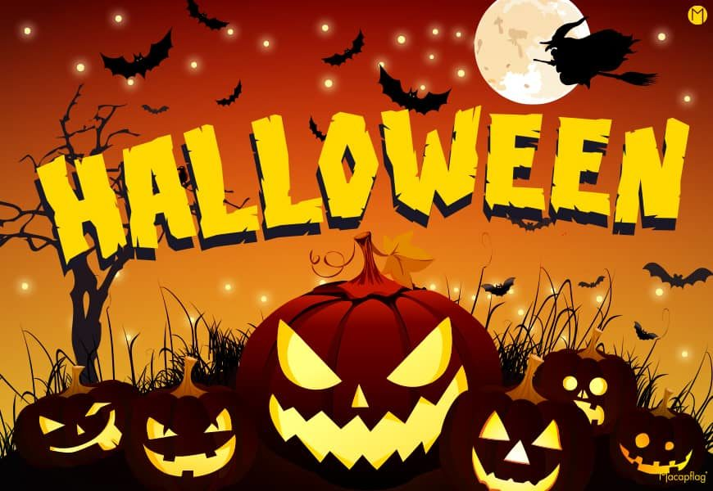
Halloween
Source : https://en.islcollective.com/video-lessons/healthy-halloween-treats

1) What treats are they making?
Fill the gap: Super ________________________ Halloween treats.

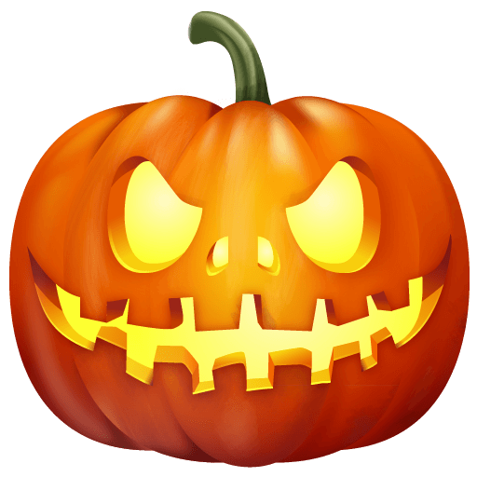
2) Whose fingers are they going to make?
- Zombie's fingers.
- Mummy's fingers.
- Witch's fingers.
3) What are they made of ? Answer the question using your own words

4) Correct the wrong word: They're putting the ingredients into the oven.

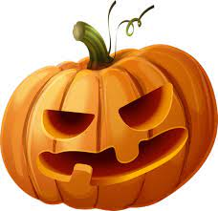
5) What nuts do they use?
- Cashew and walnuts.
- Walnuts and hazelnuts.
- Almond and cashew.

6) Put the words in order: dates. got of We've 100 grams a chopped

7) What was Theo trying to do? Answer the question using your own words

8) What makes chocolate flavour in witch's fingers?
Fill the gap: A tablespoon of ________________________ powder.

9) Put the words in order: altogether just blend gonna again. We're this

10) How many fingers can you make? Answer the question using your own words

11) Correct the wrong word: These little Jack o'Lanterns are made of pineapple and celery.

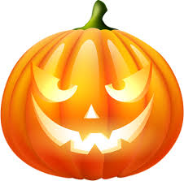
12) What kind of butter can you also use if you don't have the first one?
- Almond butter.
- Peanut butter.
- Cashew butter.

13) The flaked almonds are used for... Answer the question using your own words

14) Three types of fruit are used for monster's mouth. Which?
Fill the gap: Apples, strawberries and ________________________ (dried fruit) are used.

15) Put the words in order: treats. and our delicious, super quick very These and are scary Halloween tasty

